8.3-20

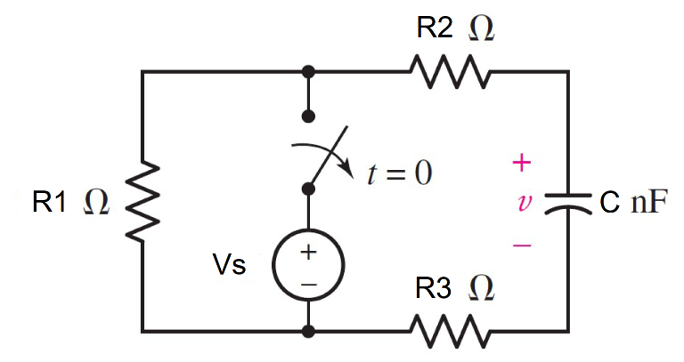

**Given**

R1= Ω, R2= Ω, R3= Ω, C = nF, Vs = V

**Find**

for t≥0

τ =C*Req

v(t) = v(0+)*exp^(-t/τ) V

Find v(t) at t = 1τ, 2τ and 5τ

By substituting a t in the v(t) equation

**Random variables**

R1 = {100:500:100}

R2 = {100:500:50}

R3 = {100:500:50}

C= {1e-9:5e-9:1e-9}

Vs = {1:10:1}

**Global variables**

v(0-)=Vs

v(0+)=v(0-)

Req =R1+R2+R3

τ =C*Req

**Answer**

1. τ = s.
2. v(t) at t = 1τ, 2τ and 5τ

**Ex.**

Given R1= 200Ω, R2= 100Ω, R3= 150Ω,

C = 2nF, Vs = 4V

#t≥0

v(0+) = v(0-) = 4 V

Req =R1+R2+R3 =200+100+150

=450 Ω

τ =C*Req=2x10-9*450

=**900x10-9 s.**

v(t) = v(0+)*exp^(-t/τ) V

= 4*exp^(-t/900x10-9) V

Find v(t) at t = 1τ, 2τ and 5τ

v(1τ) = 4*exp^(-1τ /τ) v = **1.47152 V**.

v(2τ) = 4*exp^(-2τ /τ) v = **0.541341 V**.

v(5τ) = 4*exp^(-5τ /τ) v = **0.02695V.**

8.3-21

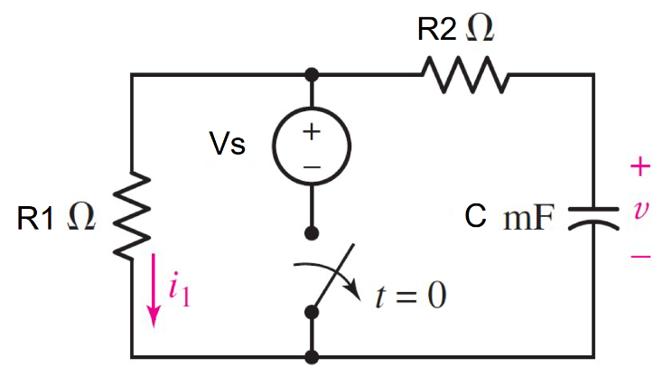

**Given**

R1= Ω, R2= Ω, C = mF, Vs = V

**Find**

for t≥0

τ =C*Req

i1(t) =i1(0+)*exp^(-t/ τ)mA

Find Power dissipated by R1 at t =500 ms

P(t)=i1(t)*i1(t)*R1 w.

**Random variables**

R1 = {100:500:100}

R2 = {100:500:50}

C= {10e-3:50e-3:10e-3}

Vs = {1:10:1}

**Global variables**

v(0-)=Vs

v(0+)=v(0-)

Req =R1+R2

τ =C*Req

vr1(0+) = (R1/(R1+R2))*v(0+)

i1(0+)= vr1(0+) /R1

**Answer**

1. τ = s.
2. i1(t)
3. P(t)

**Ex.**

Given R1= 12Ω, R2= 9Ω, C = 50mF, Vs = 8V

#t≥0

Req =R1+R2 =12+9 = 21 Ω

τ =C*Req=50x10-3*21

=**1.05 s.**

v(0+) = v(0-) = 8V

vr1(0+) = (R1/(R1+R2))*v(0+)

= (12/21)*8 = 4.571 V.

i1(0+) = vr1(0+) /R1 = 4.571/12

= 0.380952 A.

i(t) =i(0+)*exp^(-t/ τ)

= **0.380952*exp^(-t/1.05) A**

Find Power dissipated by R1 at t =500 ms

P(500x10-3) =i1(500x10-3)*i1(500x10-3)*R1

= **0.671905 W**

8.3-22

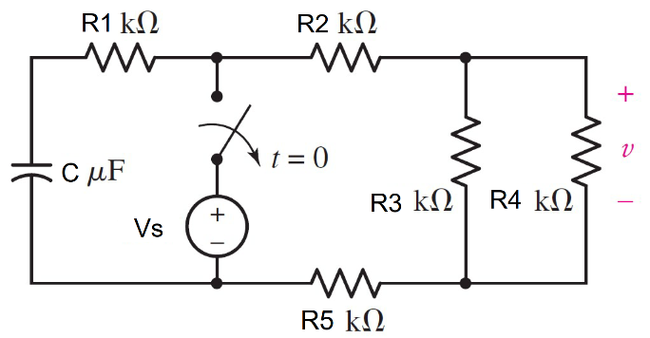

**Given**

R1= Ω, R2= Ω, R3= Ω, R4= Ω, R5= Ω,

C = µs, Vs = V

**Find**

for t≥0

τ =C*Req

v(t) = v(0+)*exp^(-t/τ) V

w(t)=0.5*C*v(t)*v(t)

Find w(t) at t = 170 ms

By substituting a t in the w(t) equation

**Random variables**

R1 = {1000:20000:1000}

R2 = {1000:5000:1000}

R3 = {1000:5000:1000}

R4 = {100:1000:100}

R5 = {1000:10000:1000}

C= {1e-6:10e-6:1e-6}

Vs = {1:20:2}

**Global variables**

Req =(R4*R5/R4+R5)+R1+R2+R3

τ =C*Req

vc(0-)=Vs

vc(0+)=vc(0-)

i(0+) = vc(0+)/Req

v(0+)=i(0+)* (R3*R4/R3+R4)

**Answer**

1. τ = s.
2. v(t)
3. w(170ms)

**Ex.**

Given R1= 20kΩ, R2= 3kΩ, R3= 5kΩ,

R4= 1kΩ, R5= 10kΩ, C = 5µF, Vs = 12 V

#t<0

vc(0-)=Vs = 12v

#t≥0

vc(0+)=vc(0-) = 12 V.

Req =(R4*R5/R4+R5)+R1+R2+R3

=(1000*5000/6000)+20000+3000+10000

=33833Ω

τ =C*Req=5x10-6*33833

=**0.169 s.**

i(0+) = vc(0+)/Req

= 12/33833 = 0.3546 mA

v(0+) =i(0+)* (R3*R4/R3+R4)

=0.3546x10-3 *(1000*5000/6000)

= 0.2955 V.

v(t) =v(0+)*exp^(-t/ τ)

= **0.2955*exp^(-t/0.169) V.**

w(t)=0.5*C*v(t)*v(t)

Find w(t) at t = 170 ms

w(170x10-3)

=0.5*5x10-6 v(170x10-3)*v(170x10-3)

= **2.9248x10-8 J**

8.3-23

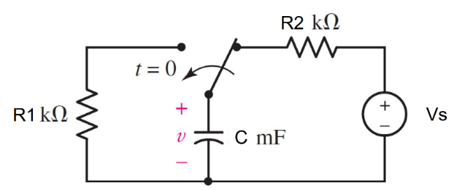

**Given**

R1= Ω, R2= Ω, R3= Ω, R4= Ω, R5= Ω,

C = µs, Vs = V

**Find**

for t≥0

v(t) = v(0+)*exp^(-t/τ) V

#Find v(t) at t = 0, 984 and 1236s

#By substituting a t in the v(t) equation

w(t)=0.5*C*v(t)*v(t)

#Find the energy store in the C at t =100s

**Random variables**

R1 = {80000:100000:1000}

R2 = {10000:30000:1000}

C= {1e-3:20e-3:1e-3}

Vs = {1:20:2}

**Global variables**

Req =R1

τ =C*Req

v(0-)=Vs

v(0+)=v(0-)

**Answer**

1. v(t) at t = 0, 984 and 1236s
2. w(t) at t =100s

**Ex.**

Given R1= 82kΩ, R2= 21kΩ, C = 12mF, Vs=20 V

#t<0

v(0-)=Vs = 20v

#t≥0

v(0+)=v(0-) = 20 V.

Req =R1 = 82000Ω

τ =C*Req=12x10-3*82000 = 984 s.

v(t) =v(0+)*exp^(-t/ τ)

= 20*exp^(-t/984) V

#Find v(t) at t = 0,984 and 1236s

v(0) = 20*exp^(-0/984) **= 20 V.**

v(984) = 20*exp^(-984/984) **= 7.357 V.**

v(1236)= 20*exp^(-1236/984) **= 5.7 V.**

w(t)=0.5*C*v(t)*v(t)

Find w(t) at t = 100 ms

w(100x10-3)

=0.5*5x10-6 v(100x10-3)*v(100x10-3)

= **1.95857J**

8.3-24

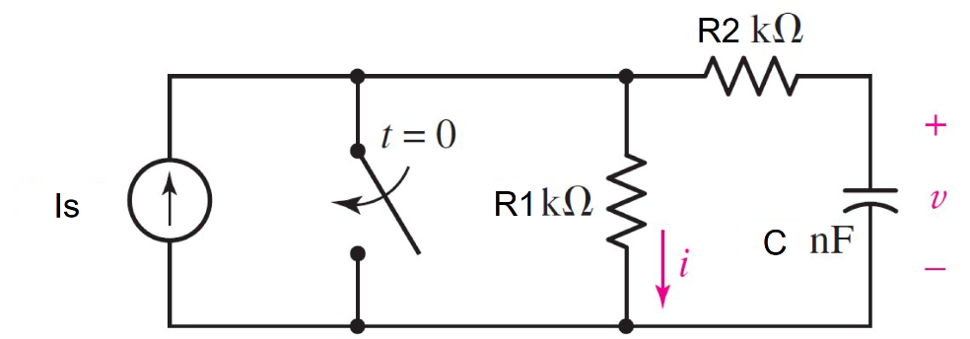

**Given**

R1= Ω, R2= Ω,C = nF, Is = mA

**Find**

for t<0

v(0-)=Is*R1

for t≥0

τ =C*Req

v(t) = v(0+)*exp^(-t/τ) V

#Find v(t) at t = 3 ms

#By substituting a t in the v(t) equation

**Random variables**

R1 = {1000:10000:1000}

R2 = {1000:10000:1000}

C= {50e-9:200e-9:50e-9}

Is = {1e-3:5e-3:1e-1}

**Global variables**

Req =R2

τ =C*Req

v(0+)=v(0-)

**Answer**

1. τ
2. v(0-)
3. v(t)
4. v(t) at t = 3ms

**Ex.**

Given R1= 10kΩ, R2= 10kΩ, C = 150nF, Is=2 mA

#t<0

v(0-)=Is*R1 = 2x10-3 * 10000 = **20v**

#t≥0

v(0+)=v(0-) = 20 V.

Req =R2 = 10000Ω

τ =C*Req=150x10-9*10000 = **1.5 ms**.

v(t) =v(0+)*exp^(-t/ τ)

= **20*exp^(-t/1.5x10-3) V**

#Find v(t) at t = 3 ms

v(3ms) = 20*exp^(-3x10-3/1.5x10-3)

**= 2.706 V.**